HOBBY APP

Aim: To Create Hobby App.

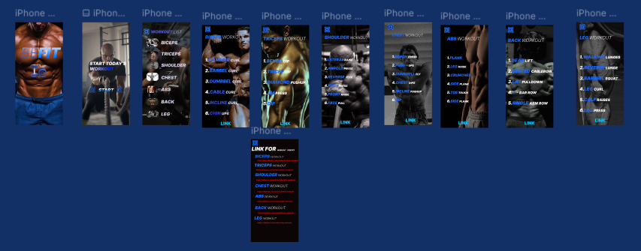

Procedure:

**Step 1: Set Up Your Figma File**

1. **Create a New File**:
   * Open **Figma** and click **File > New** to create a new design file.
2. **Create Frames (Artboards)**:
   * Use Figma’s **Frame tool (F)** to create your app screens.
   * For mobile design, use **iPhone 13/14/SE (375x812)** frame dimensions as a base.
   * Create separate frames for each screen of the app (e.g., **Splash Screen**, **Onboarding**, **Home**, **Hobby Categories**, **Profile**, **Settings**).

### **Step 2: Define the App Structure and Features**

Before jumping into the design, it's important to define the features and structure of the app. Here’s an outline of possible features:

1. **Splash Screen**:
   * Display the app’s **logo** and a tagline.
   * Keep it simple and brief, with a clean design.
2. **Onboarding**:
   * A series of introductory screens that explain the app’s purpose and features.
   * Users can swipe or tap through the onboarding process.
3. **Home Screen**:
   * Main dashboard where users can discover new hobbies, see their favorite hobbies, and navigate to other sections of the app.
4. **Hobby Categories Screen**:
   * Show different categories of hobbies (e.g., **Sports**, **Arts & Crafts**, **Music**, **Photography**, etc.).
   * Include **search bar** and **filters** for easy navigation.
5. **Hobby Detail Screen**:
   * When a user taps on a hobby, this screen provides more information about that hobby, such as description, beginner tips, and tutorials.
   * Option to **track progress** or **join hobby communities**.
6. **Profile Screen**:
   * Allows users to set up and manage their personal profiles, including interests and progress tracking.
   * Include settings like notifications, goals, and saved hobbies.
7. **Settings**:
   * Manage user settings, app preferences, and log out.
8. **Social/Community Features** (optional):
   * Users can **join hobby groups**, share their progress, and connect with other users.

### **Step 3: Design the Screens**

Let’s go through designing each screen.

#### **1. Splash Screen**

* **Logo & Tagline**: Place your app logo in the center of the screen, and add a short tagline beneath it.
  + Example: **“Explore, Learn, and Master Your Hobbies”**.
* **Background Color**: Choose a clean and engaging background color (e.g., pastel colors or gradients).
* **Animation** (optional): Add a subtle fade or transition effect for when the splash screen appears.

#### **2. Onboarding Screens**

* **Page Layout**:
  + Use a **full-screen image** or icon that visually represents the app’s purpose.
  + For example, use images of different hobbies or activity icons (e.g., books, a paint palette, a camera, etc.).
* **Text**: Keep the copy short and to the point.
  + **Screen 1**: "Welcome to HobbyApp. Discover new hobbies!"
  + **Screen 2**: "Track your progress and stay motivated."
  + **Screen 3**: "Join a community of hobbyists."
* **Buttons**: Include a **“Get Started”** button to move past the onboarding screens to the home screen.
* **Skip Option**: Add a **“Skip”** button for users who want to bypass the onboarding.

#### **3. Home Screen**

The Home screen should be the **dashboard** of the app, where users can quickly access their favorite hobbies, see new hobby suggestions, and track their progress.

* **Header**:
  + **App Name** at the top with a simple **search bar** for users to search hobbies.
  + Optionally, you can add a **profile icon** or **menu** button in the top right corner.
* **Featured Hobbies Section**:
  + Showcase a carousel or grid of featured hobbies or activities with images or icons representing each hobby (e.g., **Yoga**, **Photography**, **Music**).
  + Each hobby image should be clickable and lead to a **Hobby Detail Screen**.
* **Recommended Hobbies**:
  + Add a section with **hobby recommendations** based on user interests or trending hobbies.
* **Quick Links**:
  + Provide links to **My Hobbies**, **Goals**, and **Community**.

#### **4. Hobby Categories Screen**

This screen helps users explore hobbies by category.

* **Category List**:
  + Create a grid layout with **category cards** (e.g., **Sports**, **Arts**, **Music**, **Fitness**).
  + Use **icons or images** that represent each category.
* **Filters**:
  + Include **filters** for users to narrow down their options (e.g., by difficulty level, type, location, or popularity).
* **Search Bar**:
  + Add a prominent **search bar** at the top to search hobbies by name or keyword.

#### **5. Hobby Detail Screen**

When a user taps on a hobby, they should be taken to a detailed screen with more information about that hobby.

* **Hobby Image**: Display a large image or video related to the hobby.
* **Description**: Include a short description of the hobby and some helpful beginner tips.
* **Track Progress**: Add a **progress tracker** (e.g., how many activities or challenges they’ve completed in that hobby).
* **Community Section**: Allow users to join or view community groups related to the hobby.
* **CTA Buttons**: Include buttons like **"Start Learning"**, **"Join Group"**, or **"Track My Progress"**.

#### **6. Profile Screen**

The profile screen should allow users to manage their personal information and track their hobby progress.

* **Profile Picture**: Add a placeholder for the user’s profile picture (or use an avatar).
* **User Info**: Display the user’s name, email, and hobbies.
* **Progress Tracking**: Show a summary of the user’s completed hobbies and challenges.
* **Settings**: Include buttons to manage **account settings**, **notification preferences**, and **log out**.

#### **7. Settings Screen**

Allow users to manage their app preferences.

* **Notification Settings**: Toggle options for app notifications (e.g., new hobby recommendations, group invitations, or activity reminders).
* **Account Management**: Allow users to **update their information** or **log out**.
* **Theme Preferences**: Option to switch between **light** and **dark modes**.

### **Step 4: Visual Design**

#### **1. Color Scheme**

* Choose a **bright, friendly color palette** to keep the app lively and welcoming. Think pastel blues, greens, and oranges.
* Use a neutral base like white or light gray, with accents of vibrant colors for buttons and highlights.

#### **2. Typography**

* Use **rounded fonts** to give the app a friendly and approachable feel. Fonts like **Poppins**, **Nunito**, or **Roboto** are a good fit.
* Ensure the text is readable on smaller mobile screens.

#### **3. Icons and Images**

* Use icons that represent different hobbies (e.g., **camera icon**, **paintbrush icon**, etc.).
* High-quality images for each hobby category will enhance the user experience. You can use stock photography or create custom icons/illustrations in Figma.

#### **4. Buttons and Interactions**

* Design **CTA buttons** to be easily clickable with a friendly style (e.g., rounded edges, subtle shadows).
* Consider using **hover effects** or **tap animations** to make the app feel more interactive.
* Use **Auto Layout** in Figma to make sure buttons are well-spaced and consistent.

### **Step 5: Prototype and Interactions**

1. **Link Screens**: Use **Figma’s Prototyping feature** to connect screens and create a flow.
   * Link the **buttons** (e.g., "Get Started", "Search", "Join Group") to their respective screens.
   * Set up **scrollable areas** for lists (e.g., hobbies or categories) if necessary.
2. **Test Interactions**: Use **Presentation mode** to interact with your design and test the flow. Ensure the user experience is intuitive and that the navigation works smoothly.

### **Step 6: Handoff and Export**

1. **Inspect**: Share the Figma file with developers to inspect elements, colors, text styles, and measurements.
2. **Export Assets**: Export any images or icons used in the app design (e.g., hobby images, icons).
   * Select the assets you want to export, and click on **File > Export**.
3. **Share the Prototype**: Share the prototype link with stakeholders or users for feedback.

Result:

SuccesFully created Hobby App.